**FEATURE ENGINEERING**

INTRODUCTION

MOVING WINDOW FOR TIME SERIES

FOURIER DECOMPOSITION

DEEP LEARNING FEATURES : LSTM

IMAGE HISTOGRAM

SIFT (SCALE INVARIANT FEATURE SCHEME )

RELATIONAL DATABASE

GRAPH DATA

INDICATOR VARIABLES

FEATURE BINNING

INTERACTION VARIABLES

MATHEMATICAL TRANSFORMS

MODEL SPECIFIC FEATURIZATIONS

FEATURE ORTHOGONALITY

# **INTRODUCTION**

The most important aspect of Machine Learning is Feature Engineering

Text Data : BoW, tf-idf , word2vec are some featurization of text data. With these featurizations we convert our text into numerical data.

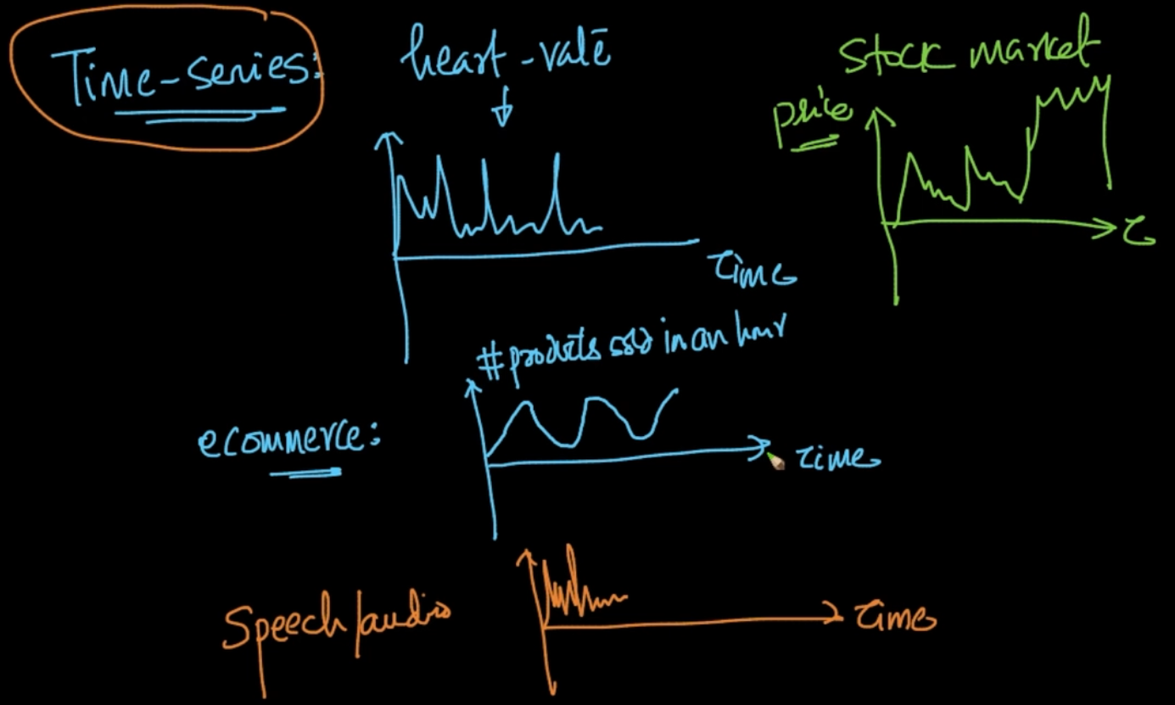

Time- Series : In e-commerce we can have time-series data where y-axis is products sold in 1 hour and x is Time. For Ex: Night can have more sales ,morning has less

We’ll learn how to convert time-series into numerical vector because after that all the classical ML algorithms can be applied there. 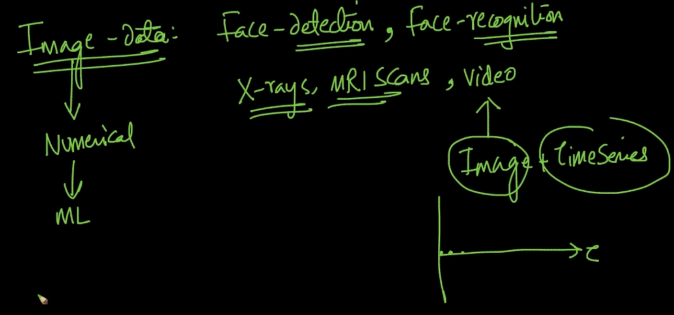

Image Data : These are the applications and type of Image data. Video is a combo of Image + Time Series. We’ll learn how to convert Image data to Numerical data

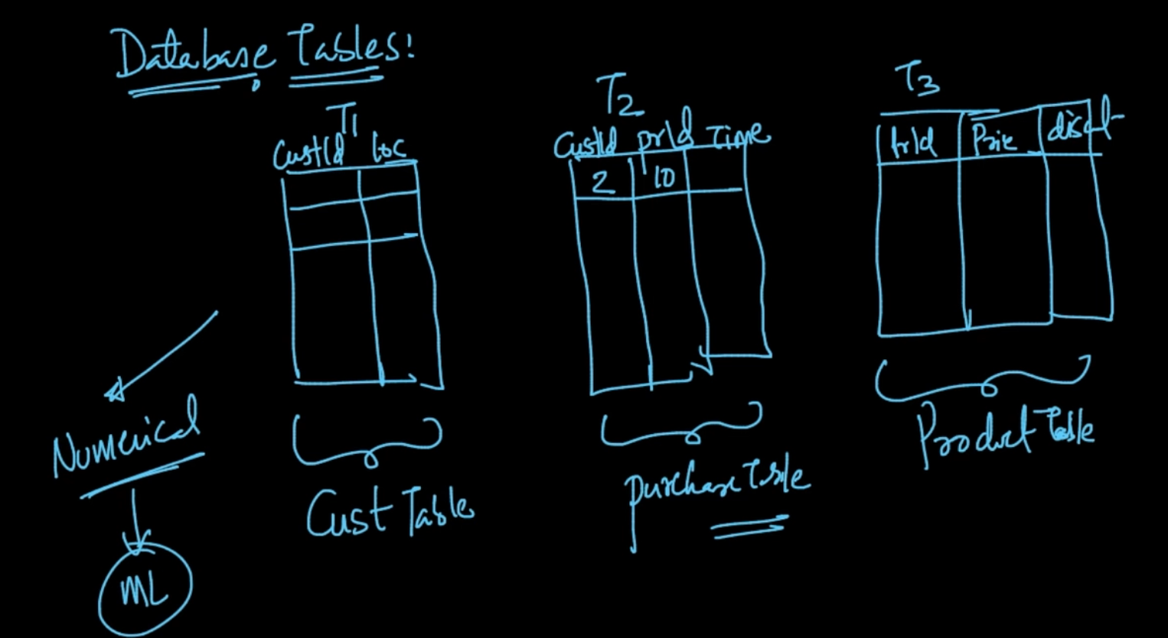

We can also have Database tables like this. We’ll see how to convert these tables into numerical vectors

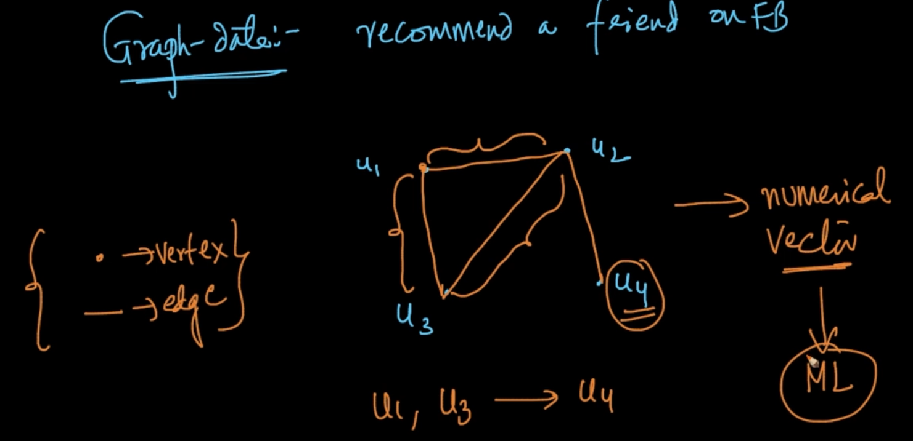

$u_{1},$ $u_{2},$ $u_{3},$ are friends $u_{2}$ is friend with $u_{4}$ so can $u_{4}$ be a friend of $u_{3}$? This is a graph data.How can we convert it into a numerical vector

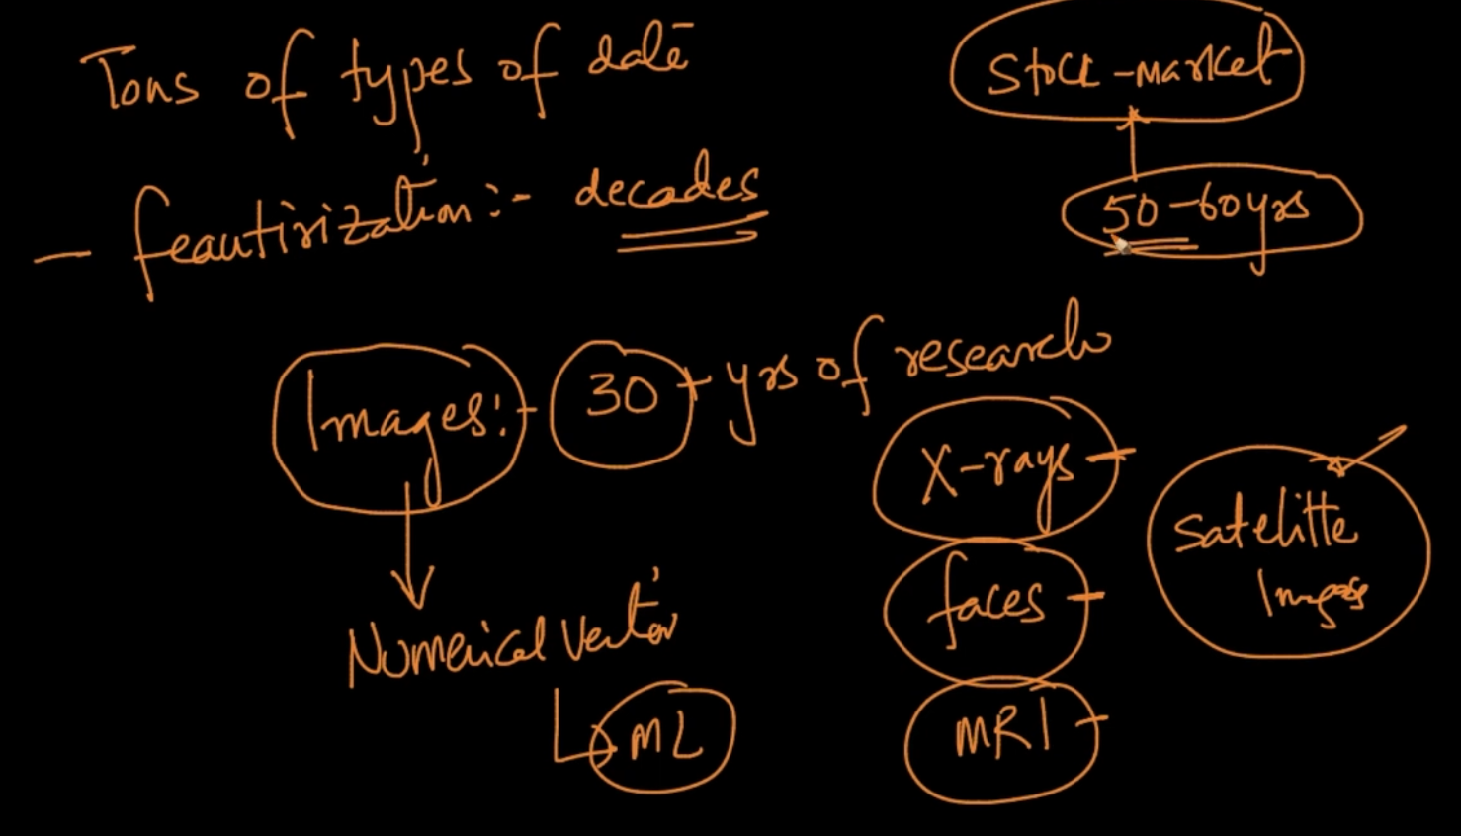

Decades have been spent on Featurization. Image featurization is 30+ years of research and there are different type of Featurization for different Image data i.e X-ray featurization is different than faces so different techniques are applied

# **MOVING WINDOW FOR TIME SERIES**

This is a time series data for ECG. We select a moving window. A moving window is data at a particular time duration like here in 1000 units of time. We should sit with a medical expert and should know what features they require. For all time points they’ve some value

We put them in a vector after that some of the standard featurizations are mean, std-deviation, max, min , max - min : The doctor can ask what’s the difference between the highest and lowest amplitude, local maxima i.e all the green points where peak is maximum in local time, zero-crossing : The doctor may ask how many times the wave/signal is going above mean.

These are not the only features we can do. If a feature is not affecting the class label then we can discard it. We should always sit with a medical expert or read literature and decide what are the feature transformations they do

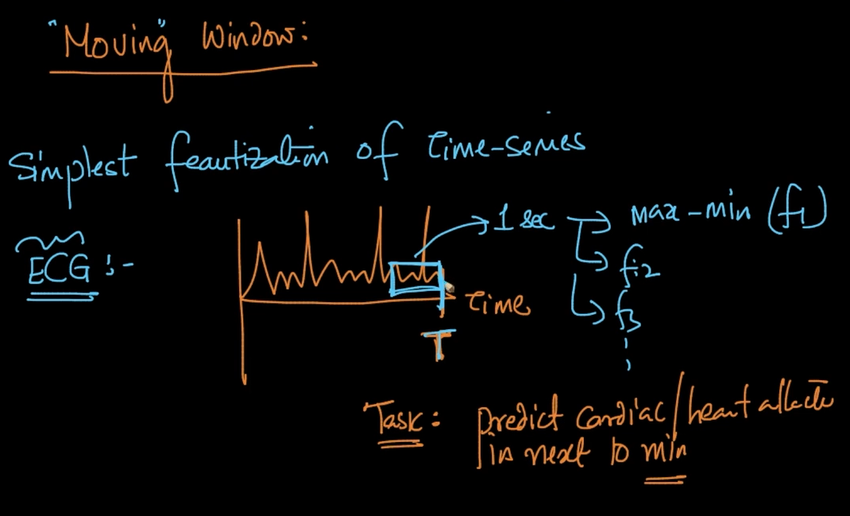

In a moving window suppose our task is to predict cardiac arrest in next 10 minutes

So we sit with a doctor (domain expert) and he’ll tell you what to look for. Suppose he says that look at the last 1 second so it’ll be our moving window and he’ll ask that calculate max- min (feature 1), how many times it’s beating (feature 2) and so on. We design the features based on Doctors opinions

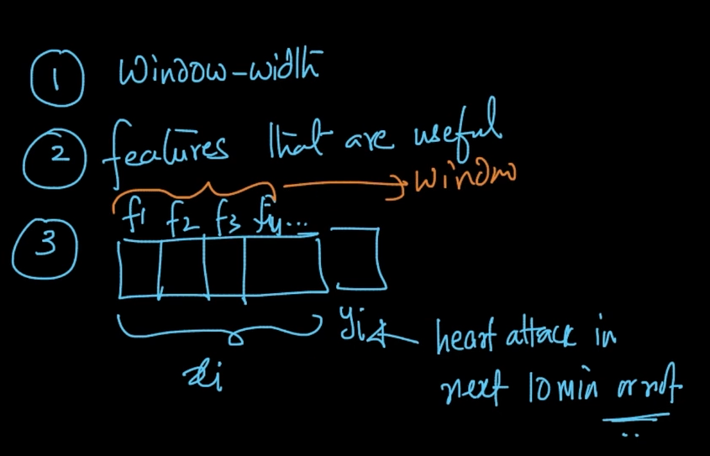

1 ) First we define what a window width is after talking to the domain expert

2 ) Then we decide what features which are useful

3 ) Then we put our features like max - min , heartbeats/ second in a vector which is our

$x_{i}$ and our $y_{i}$ is whether heart attack will happen or not in next 10 minutes

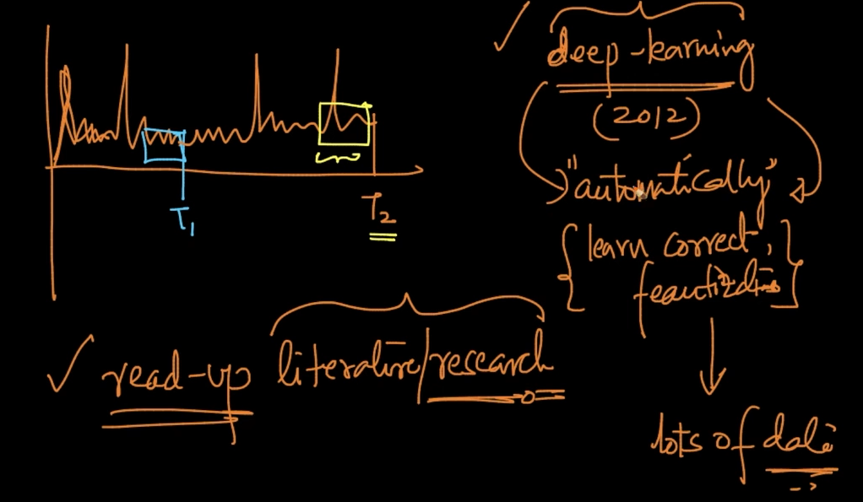

So that window was T1 now we decide to do it on T2 which is after T1. So in ML if we get the data that we know nothing of we try to read-up literature / research and try to know what are the relevant features we look for in that dataset by Googling stuff. Nowadays, Deep Learning has changed the world dramatically as it can learn correct featurizations automatically but the key thing is we need lots of data

# **FOURIER DECOMPOSITION**

**AMPLITUDE :** The height of the wave

**TIME PERIOD (T) :** Time taken for one oscillation of wave

**FREQUENCY :** If the wave has 1 oscillation / second it’s frequency is 1 Hz .It’s 1/T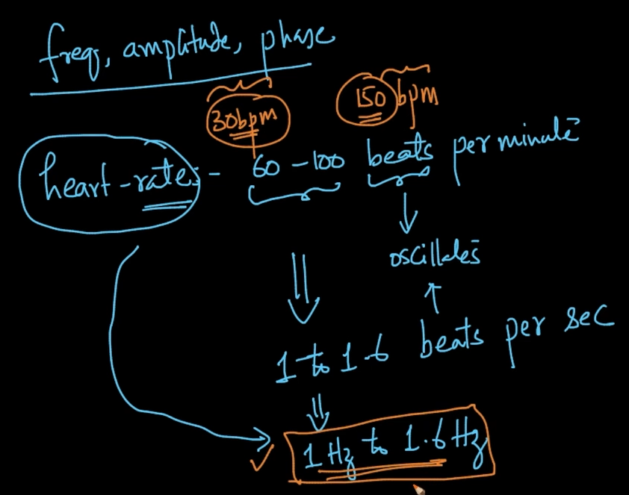

Frequency can help us determine some kind of diseases in hearts

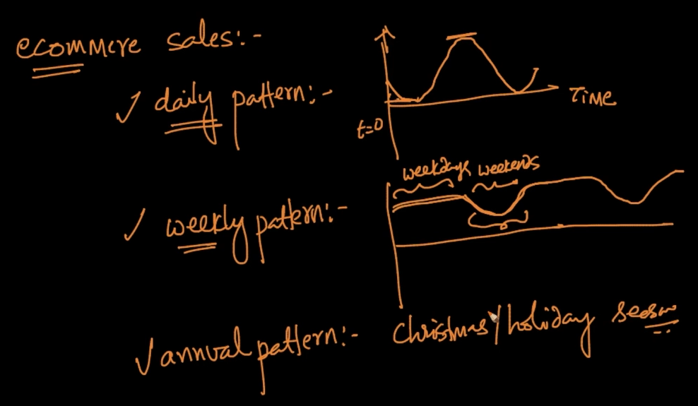

These are the daily, weekly and annual pattern of E-commerce sales. Whenever we see a repeating seeing it’s frequency is a good idea

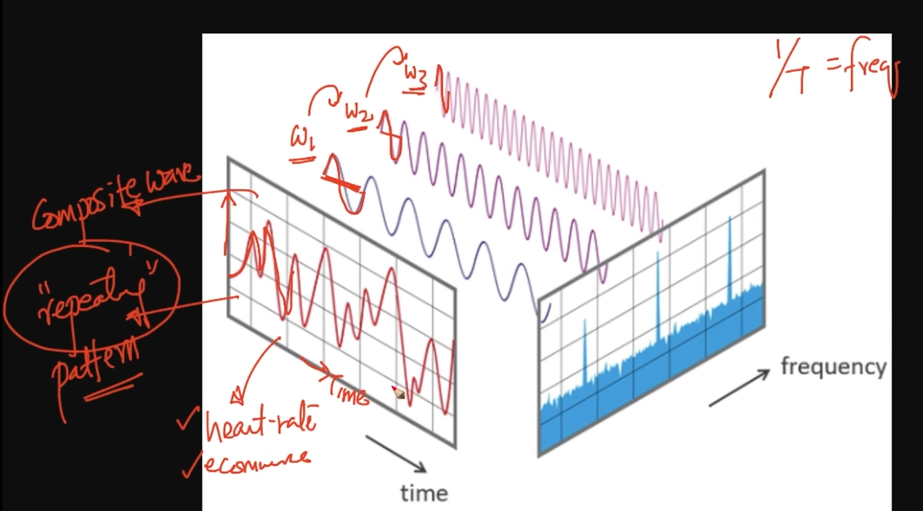

The red wave is also called a composite wave. So whenever we see a repeating pattern we can de-compose it into multiple sine waves as seen $w_{1}, w_{2}, w_{3}$.The summation of these 3 sine waves i.e $w_{1}+ w_{2} + w_{3}$ makes the composite wave .This is Fourier Transform

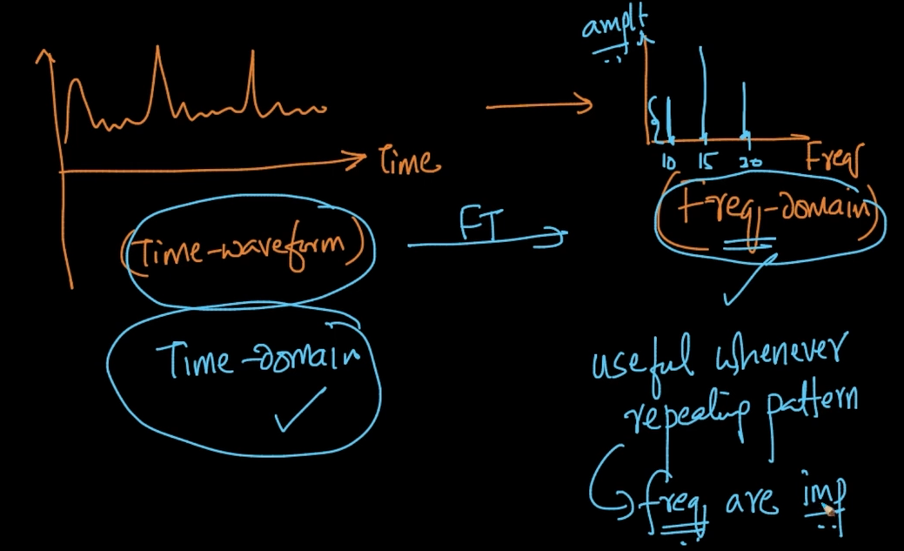

Whenever we’ve a Time-waveform like this we can apply Fourier Transform and we get some Frequencies of the decomposed waves. We plot a graph of the frequency called Frequency Domain . Here y-axis is Amplitude. Whenever useful repeating pattern is seen frequencies are important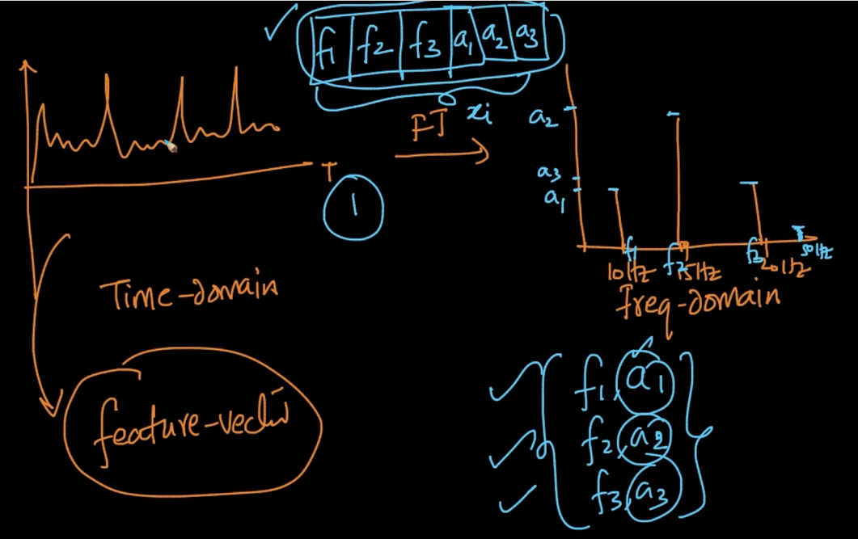

When we represent it in Frequency domain we get frequencies and amplitudes . These are used as features or $x_{i}$ as seen above

# **DEEP LEARNING FEATURES : LSTM**

Whatever features are designed for Heartbeats cannot be implemented to Speech or E-commerce time-series

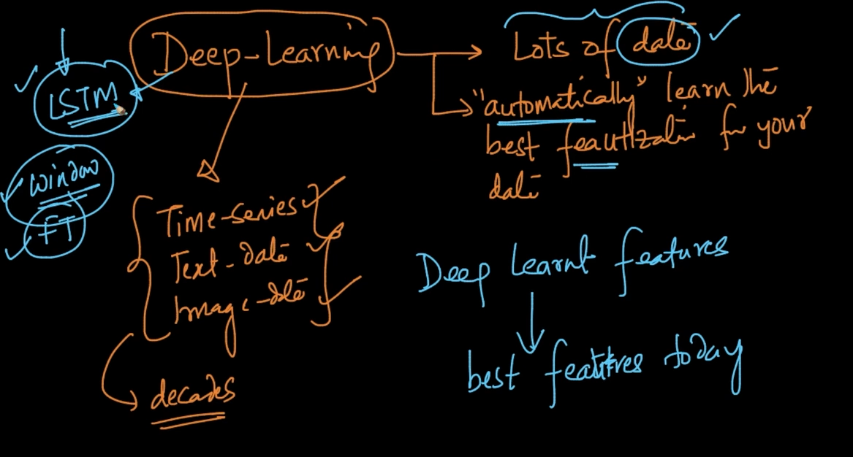

With Deep Learning if you’ve lots of data it’ll automatically learn the best features for your data

# **IMAGE HISTOGRAM**

An image with dimensions n * m has 3 colors basically RGB and each color has an intensity value ranging from 0-255. So for all pixels I can take Red values (n * m ) data points and plot a histogram .If the value of red pixel 10 occurs 30 % or 0.3 we’ll put 0.3 in the vector for 10 as seen above . So, we put the values of all intensity values from 0-255 in a vector of 255. Same can be done for Green and Blue

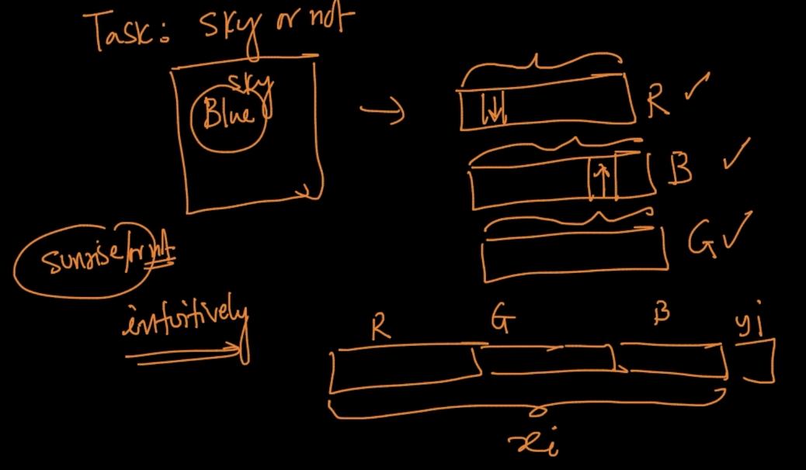

If the task is Sky or not. We know that Blue vector value will be larger and Red will be lower

So for this task we concatenate all the RGB vectors as seen above .It;ll be our $x_{i}$ and task will be our $y_{i}$ 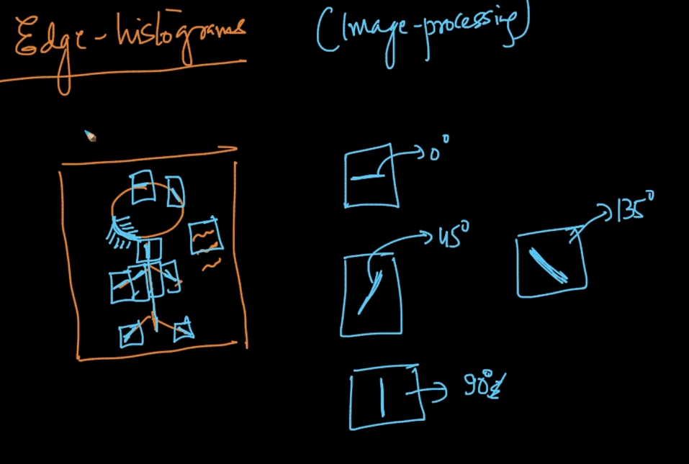

We can store angles of the Edges as shown above

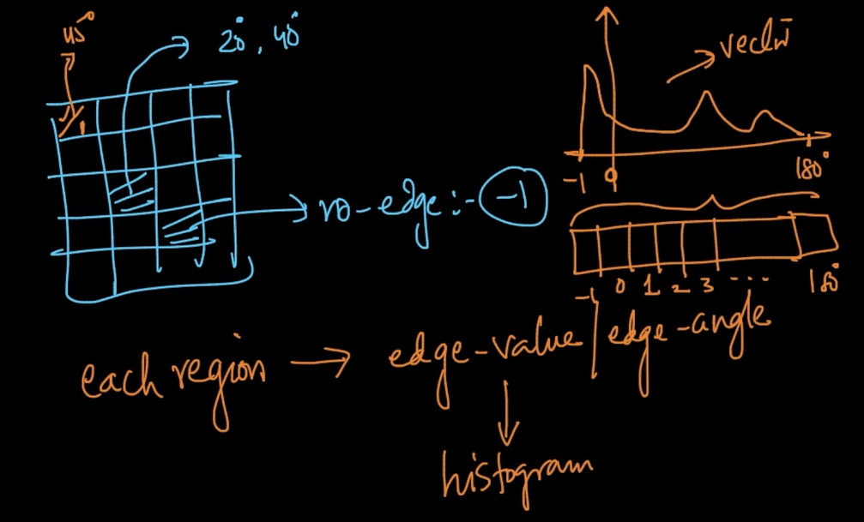

So we break our image in grids and store their angle value.If no edge then -1 and if 2 edges like in top left corner we select the dominant edge i.e 45 degree there. After that we plot a histogram of all the values -1 to 180 and put the y-axis (frequency) value in a vector

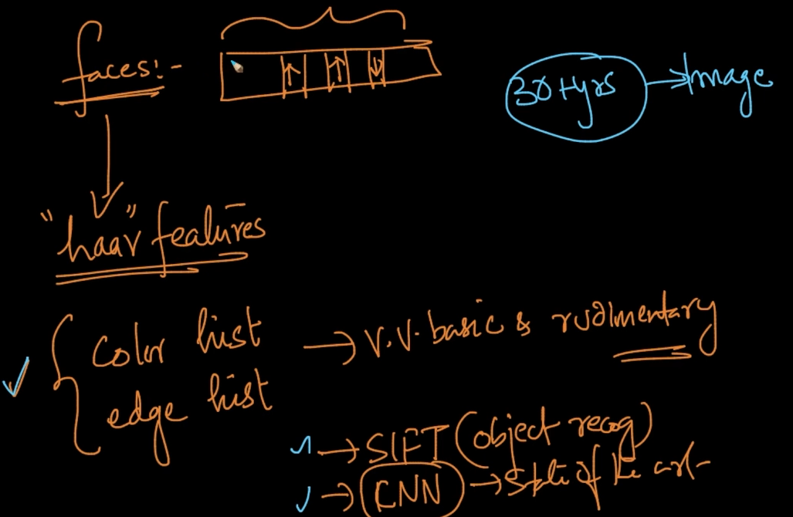

Methods for Face detection

# **SIFT (SCALE INVARIANT FEATURE SCHEME )**

SIFT is an object detection method where the algorithm finds keypoints. Keypoints are points which are easy to detect. For each point 128 dimensional vector is created

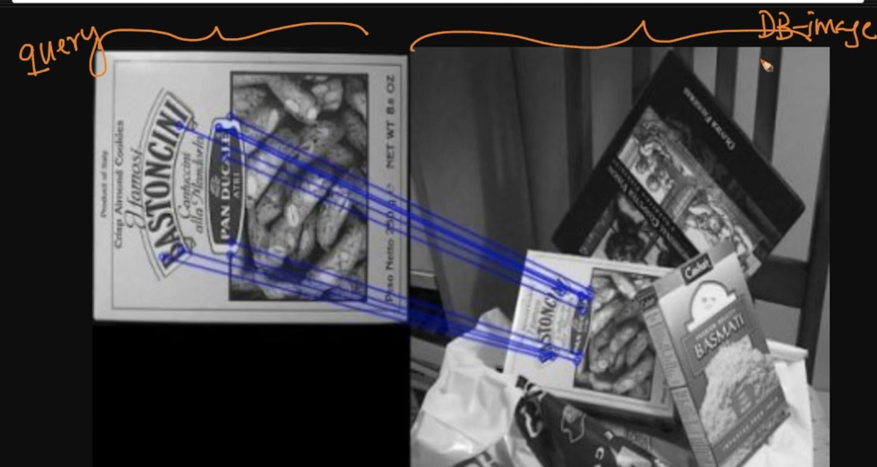

So if we want to detect that image in an image it’s called query and the data is called Database-Image

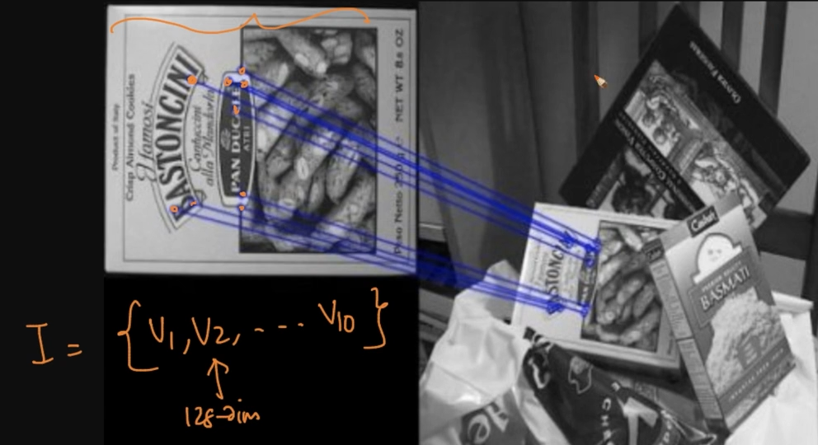

If we already have that image and we’d completed its features then we’ll have a set of all the vectors

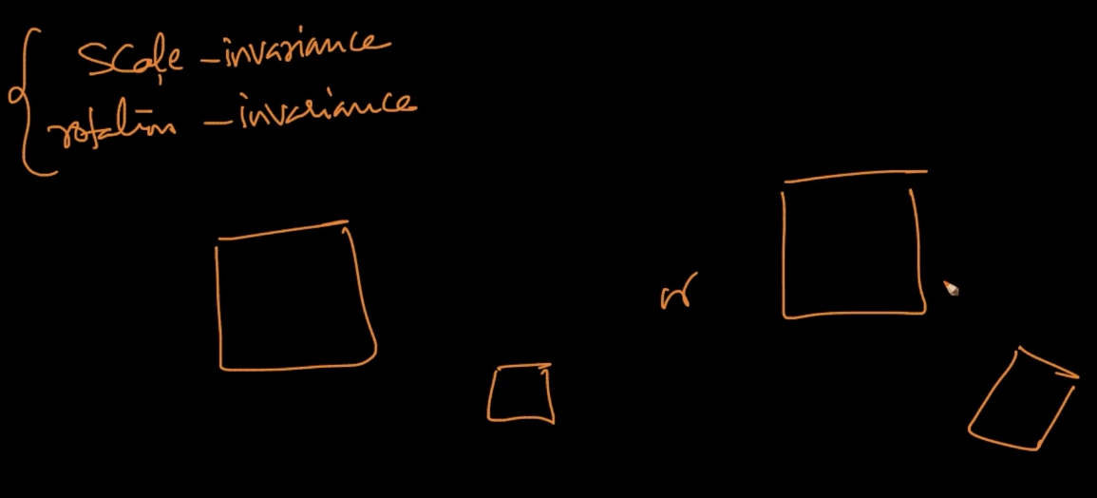

**Scale-Invariance :** It means features can be detected even when the Query is shrunk or big in size as seen for the above where query is big in size but features can still be detected

**Rotation - Invariance :** It means features can be detected even when the Query is slightly rotated as seen for the above where database image is rotated but features can still be detected

# **RELATIONAL DATABASE**

When we have multiple tables like these then we call it Relational Database .They exist in multiple form like Oracle, MySQL, SQLServer.

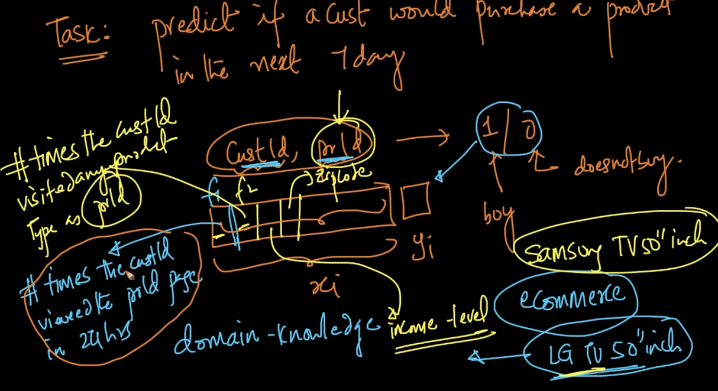

We can design features like these as seen to predict y and this can be done by groupby operations on the above SQL tables as these features are in different tables .We combine them

# **GRAPH DATA**

This is the social-graph for Friends on Facebook

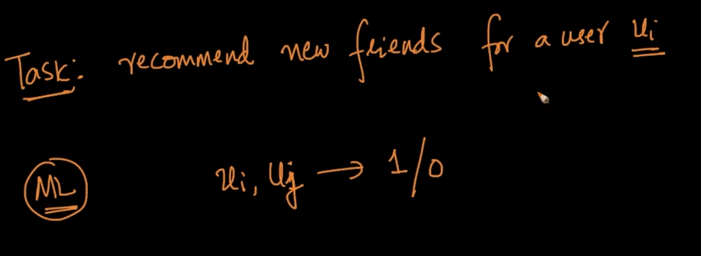

If two users are friends => 1 else => 0

So we are predicting friends for user $u_{4}$. Who has the better chance for being his friend?

$u_{3}$ or $u_{7}$

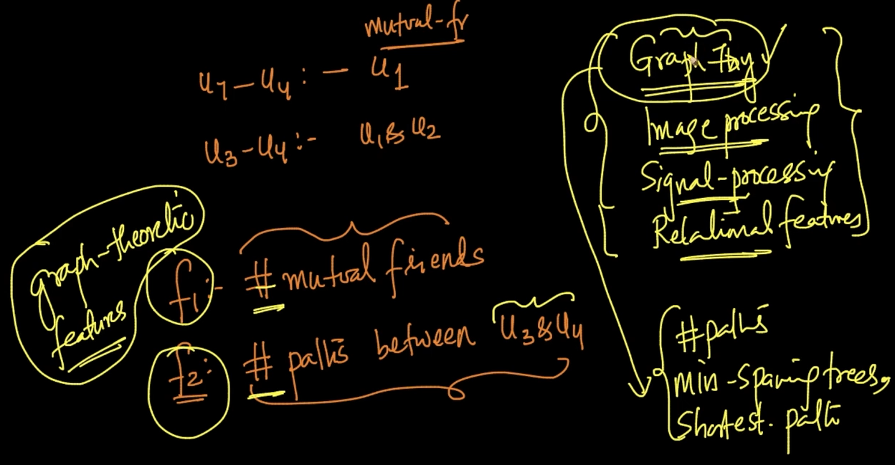

For the problem we can design features

$f_{1}$: No. of mutual friends .Obviously if more better chances of being them friends

$f_{2}$: No. of paths between users because if more paths then more chance of being friends

These features are called graph-theoretic features and they are designed with Graph theory algorithms like minimum spanning trees, shortest path etc

Remember Graph theory is fucking vast. So just study whatever is needed

# **INDICATOR VARIABLES**

Suppose we are using “height” as a feature. It’s a real valued feature and we’ve a condition that h > 150 --> 1 and h < 150 → 0. Here, if we can use indicate height as binary indicator variable i.e h = 1 if h > 150 cm else h = 0

But why just 150 ? It’s our threshold and it is very problem specific though

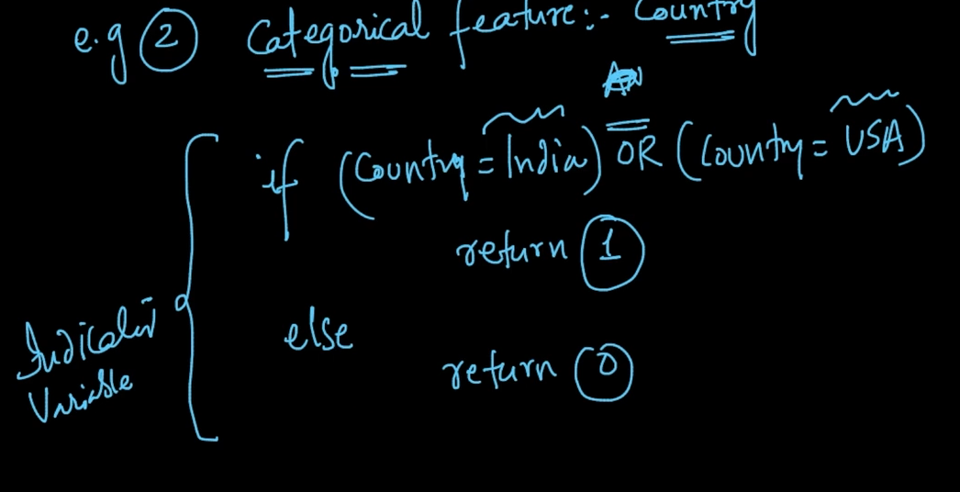

We can also us categorical features as indicator variables as shown above

# **FEATURE BINNING**

Feature Binning is an extension to Indicator variable . Here, instead of an Binary Indicator Variable we are binning the data into multiple values (4 bins/buckets). The thing is how do we do feature binning. 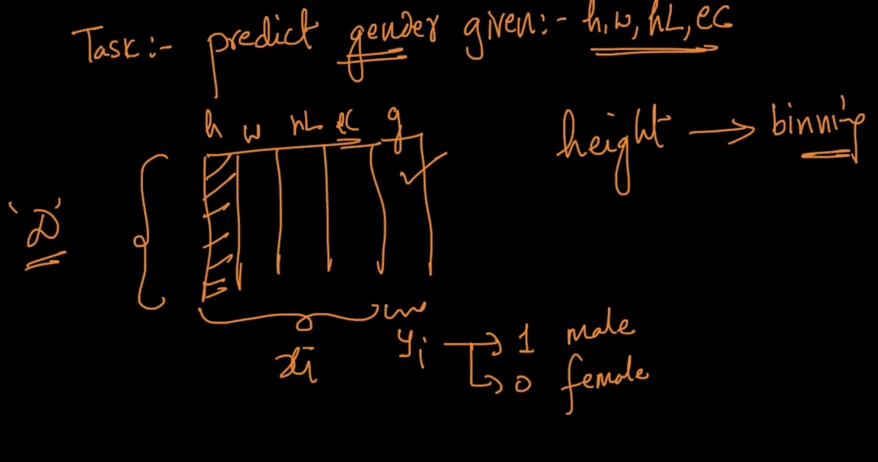

We want to bin our height here

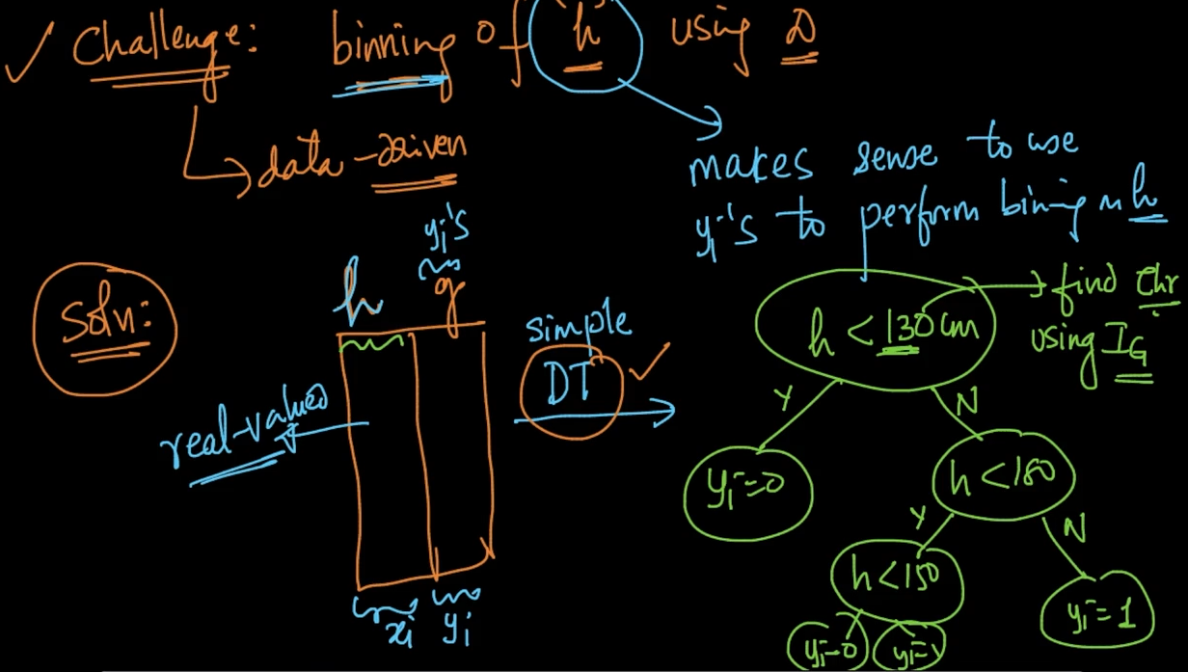

So our challenge is how do we do binning of ‘h’ using D

Solution : We create a new dataset with ‘h’ as x and y. We create a simple Decision Tree using that.

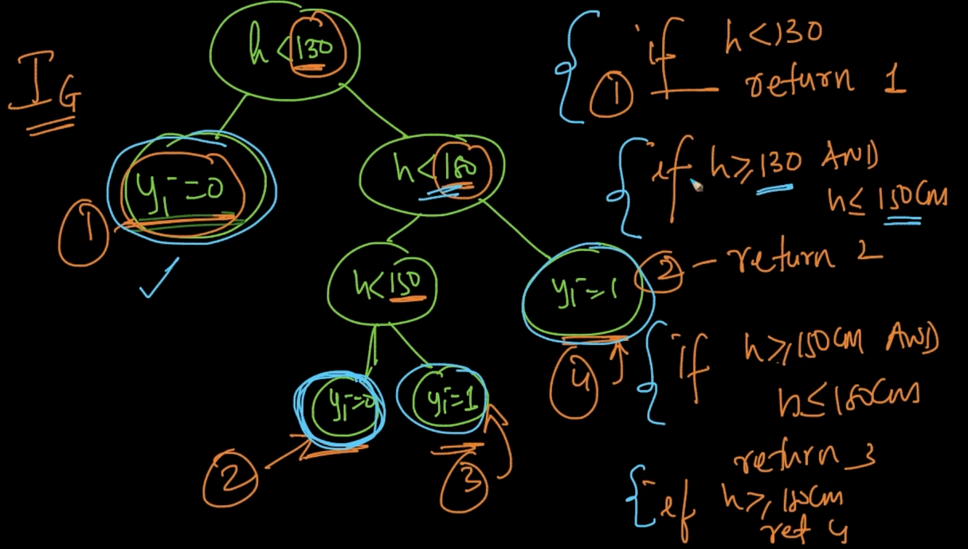

Using Information Gain we get our thresholds as seen.These thresholds can be used for feature binning .Hence, using Decision Tree for feature binning is an excellent idea

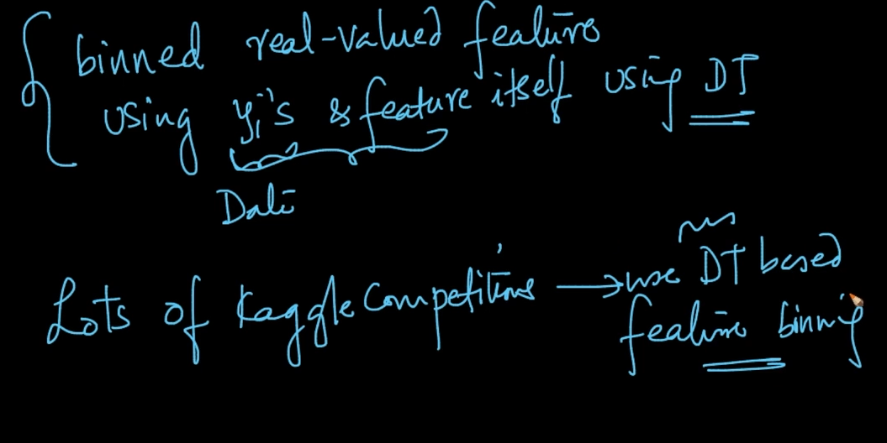

So Decision Tree model is used for feature engineering

# **INTERACTION VARIABLES**

Interaction Variable means two or more features interacting as seen above. Here, height and weight are combined to make a new feature $f_{1}$ = 1. SInce two features combining it’s called 2 way interaction feature

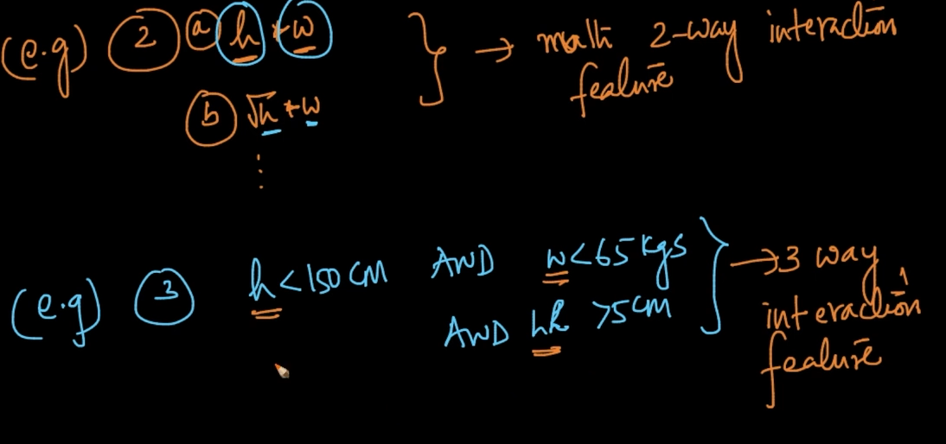

Same as above

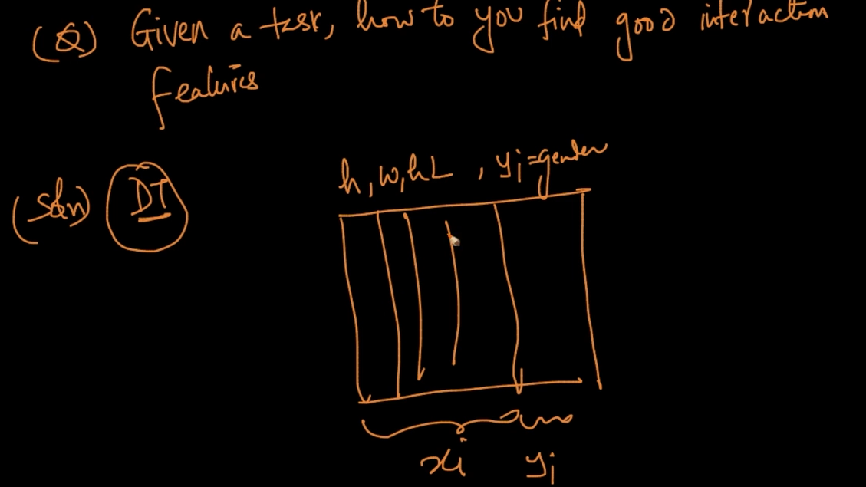

We find good interaction features by using Decision Trees on dataset

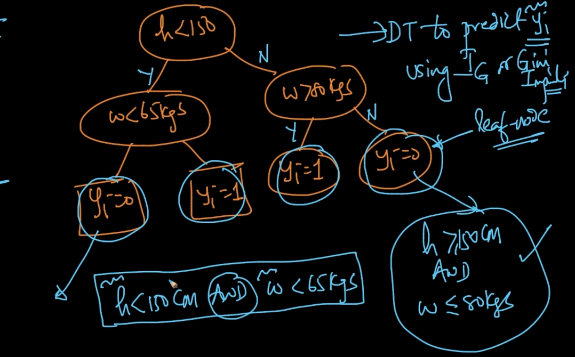

For every leaf node in the Decision Tree we can create Interaction Variable .

Ex : In the leftmost y = 0 our interaction variable is h < 150 cm AND w < 65 kgs. These Interaction Variables are very important as it’s made by DT using Information Gain to predict y

# **MATHEMATICAL TRANSFORMS**

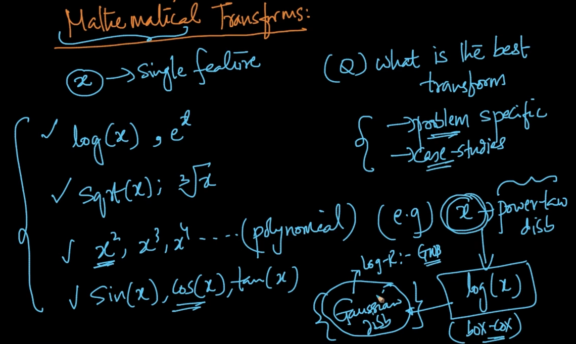

We can apply mathematical operations like log, e , sqrt, $x^{2}$ and so on in our feature x

What is the best transform ? It’s very problem specific. Ex : If our feature x is power law distribution we can apply log(x) to make it Gaussian Distribution

# **MODEL SPECIFIC FEATURIZATIONS**

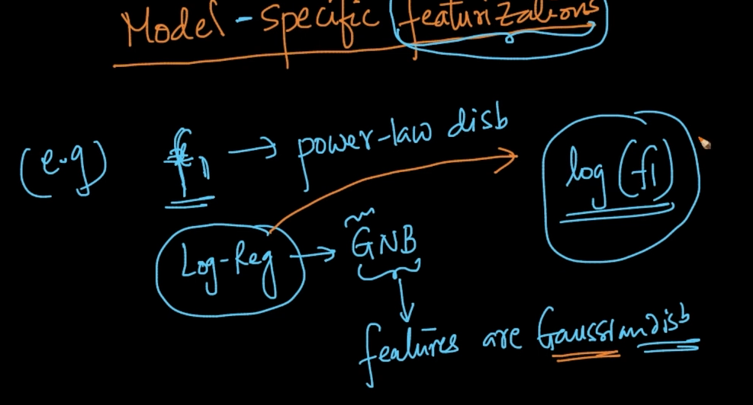

Suppose our feature ‘f’ is power law distribution and we want to apply Logistic Regression

We know that LR is Gaussian Naive Bayes (GNB) and we know that GNB looks for featuers which are Gaussian Distribution .So we can apply log(f) because we know that if f is power law then log(f) will make it Gaussian Distribution

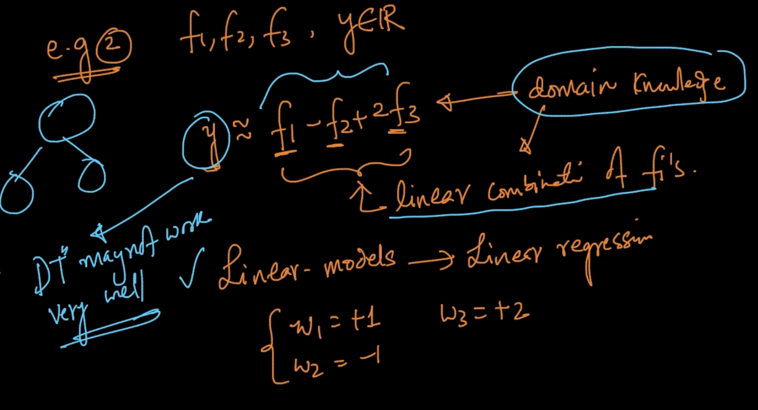

If we know that y = $f_{1}-f_{2}+{2f}_{3}$ with domain knowledge we can apply linear models since it’s a linear combination of f and these combos work very well with Linear Regression

Here DT may not work very well since it’s an if-else and it doesn’t capture essence like linear models

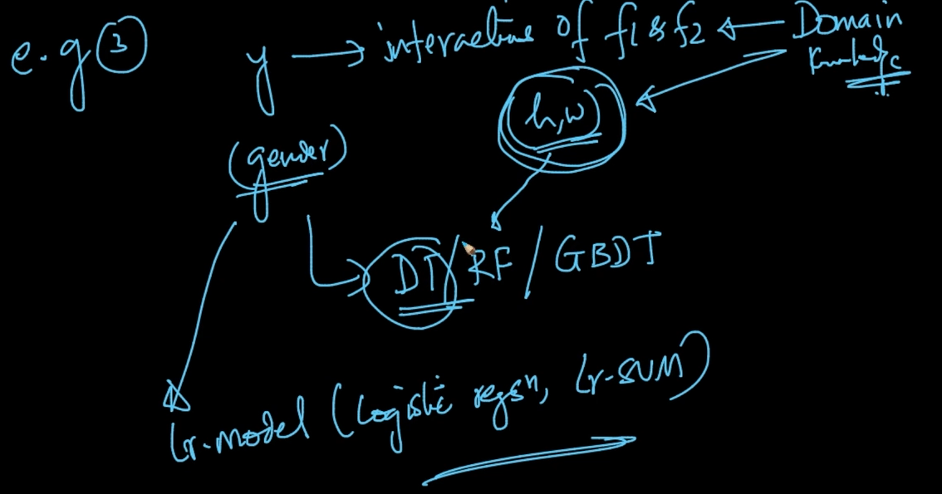

If the features are interactive as seen in the previous lecture DT/RF/Tree based methods

Linear Models doesn’t work well with these interactive variables

# **FEATURE ORTHOGONALITY**

The more different our features are the better our models will be. If our features are correlated with ‘y’ then our model will work very well but if features are correlated with themselves then the overall impact of features will be less in model even when they are correlated with ‘y’.

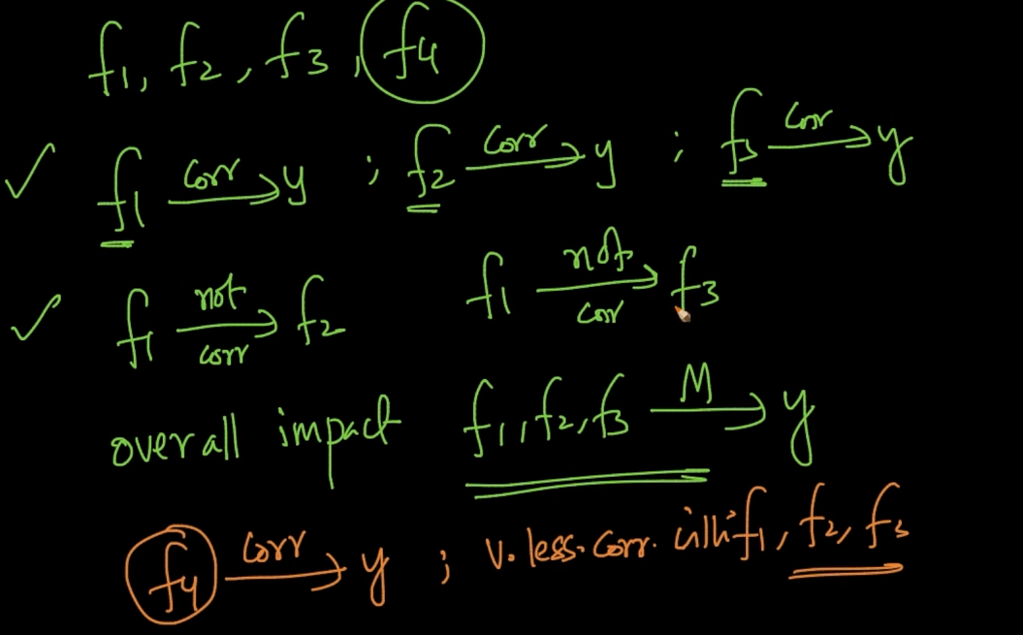

But if features are correlated with y but not with each other then their overall impact will

be very more

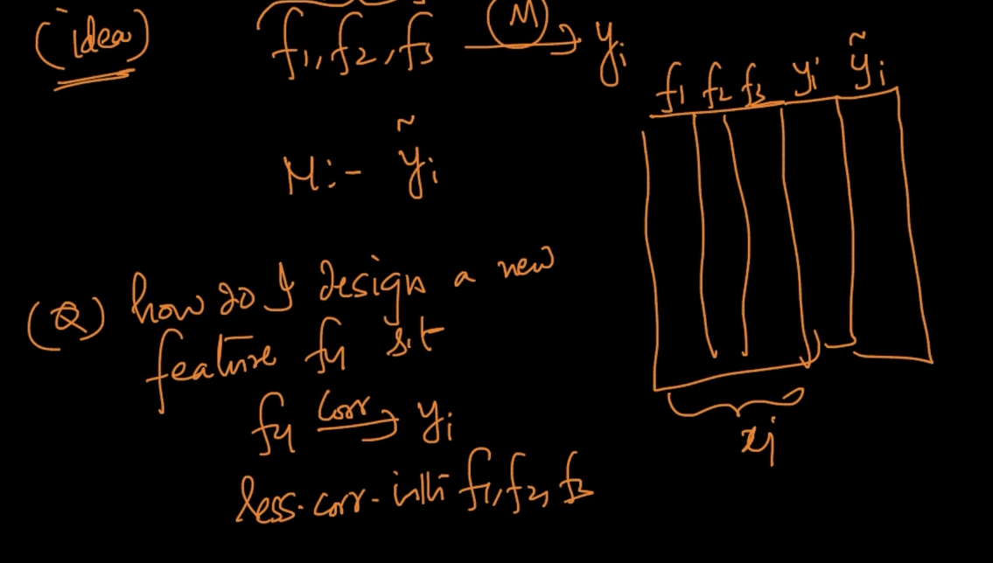

How do we design a new feature s.t it’s correlated with y but not with other features?

First of all we create a model with the existing features. We’ll get y_pred => $\underline{y}$ and already existing y_true $y_{i}$

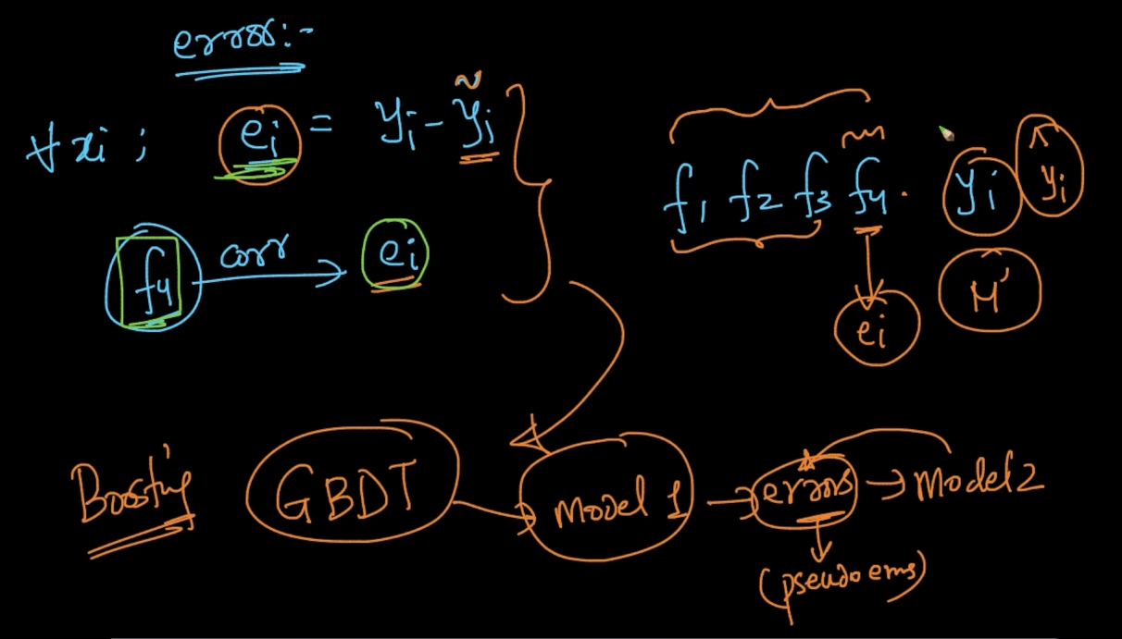

Error = y_true - y_pred. We should try that our new feature should be correlated with error

because if we do that then the model will work better after adding the new feature.This is same as Gradient Boosting because we built a model with errors from previous models

Here, we calculate errors with existing features and then we add a new feature correlating it with error

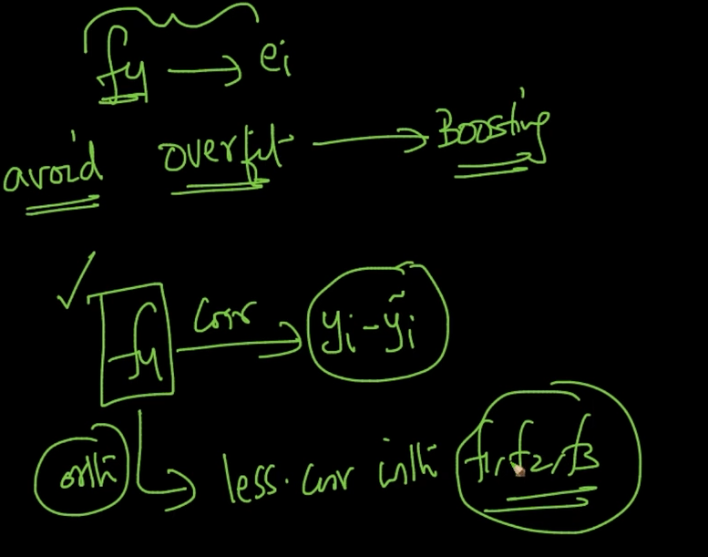

We should keep in mind that our feature should not overfit and be correlated with error

# **DOMAIN SPECIFIC FEATURIZATIONS**

If you tackle a problem in which you’re not an expert in please read the existing research and featurizations and if you’re good then you can design even new features

# **FEATURE SLICING**

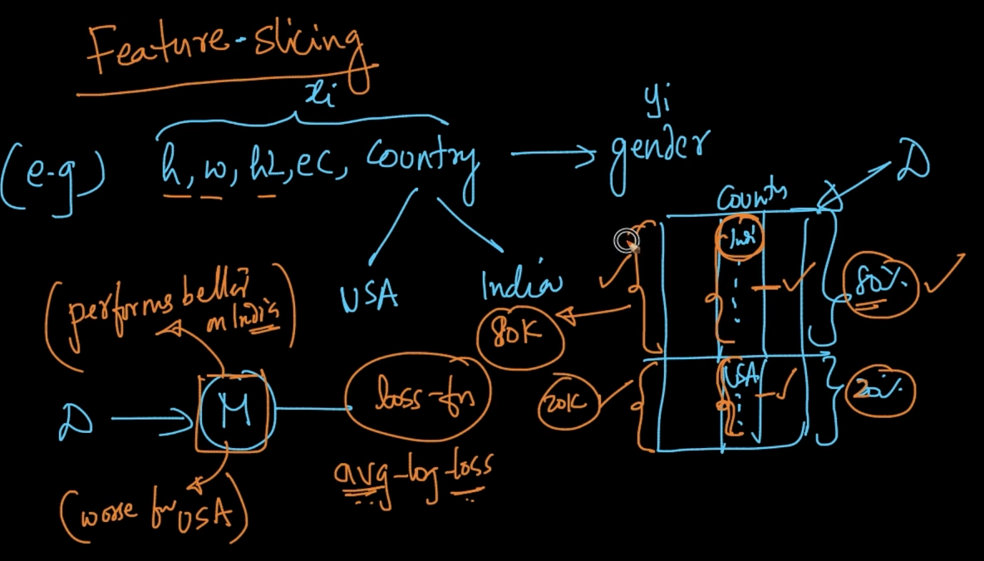

If we’ve a dataset D such that Indians are 80 % and Americans 20 %. After training our model it’ll perform much better on INDians and worse for Americans

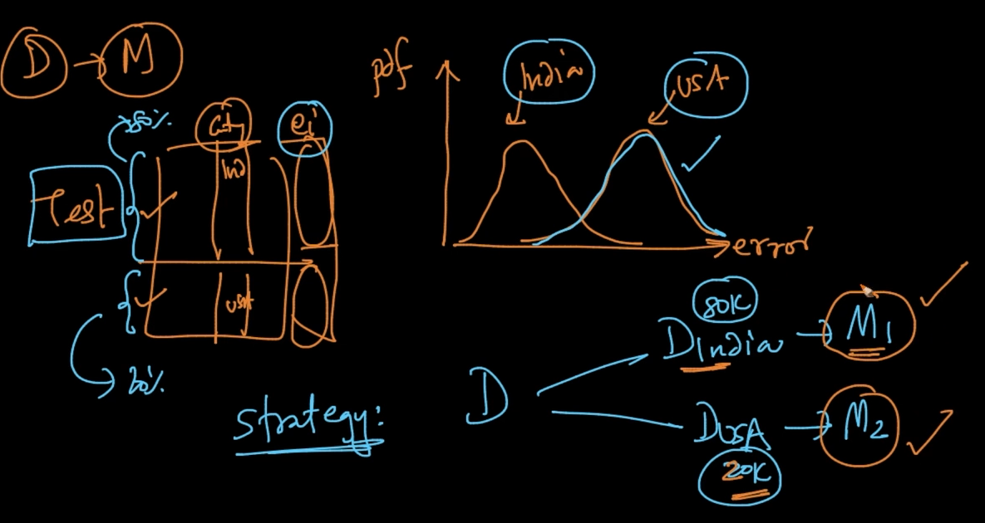

So for this we put our test data and check the error on both Indians and USA. We see that error is more for US people. So we can simply divide our data D in $D_{INDIA} \& D_{USA}$ and train

models $M_{1}$ and $M_{2}$ respectively

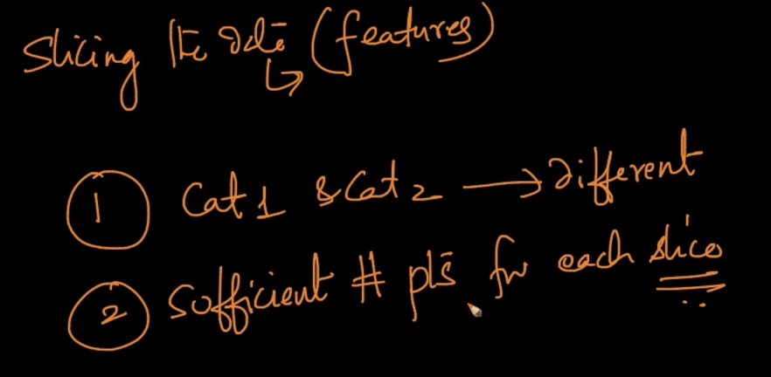

Slicing the data is based on features. Some conditions are

1 ) Both the categories of data should have distinct features. Like for US and Indians

2 ) Sufficient number of points for every slice. If we don’t have enough data then it can’t be trained very well obviously